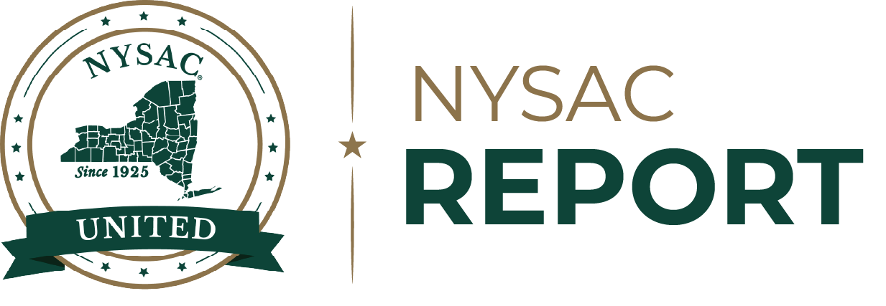

Supplemental Nutrition Assistance Program (SNAP)
New Costs, New Requirements,
New Risks for New York Counties

Introduction
The Supplemental Nutrition Assistance Program (SNAP) is the nation’s largest food assistance program. It helps children, seniors, people with disabilities, working families, and residents facing financial hardship buy groceries and maintain access to food.
In New York State, that federal benefit is administered locally through county Departments of Social Services (DSS), guidance from the Office of Temporary and Disability Assistance (OTDA).
SNAP benefits also bring federal dollars into local economies every month, moving through grocery stores, farmers’ markets, farm stands, small businesses, and local food producers. In Onondaga County alone, more than 62,000 residents rely on SNAP, representing approximately $150 million in benefits flowing into the local economy.
H.R.1 (the “One Big Beautiful Bill Act”), signed into law on July 4, 2025, will significantly alter SNAP funding, administration, and eligibility. When H.R. 1’s administrative cost shift takes effect in October 2026, SNAP recipients will continue to need food assistance, while DSS staff will have to explain more rules, verify more documents, and the overall costs of administration will more than double.

Background
New York counties’ role in SNAP is rooted in the state’s broader public welfare history. Before the modern Food Stamp, our public welfare system had already moved away from the older Poor Law framework, which relied on local poor relief, poorhouses, and a patchwork of county-specific laws. The Public Welfare Law of 1929 reorganized that fragmented system by clarifying the financial responsibilities of counties, giving welfare officials broad authority to aid residents in need, and shifting toward home care and medical care rather than reliance on institutional poor relief.
The 1938 State Constitution reinforced that local-state responsibility by making the aid, care, and support for residents in need, a public obligation of the state and its subdivisions. By the time the federal Food Stamp Program expanded in the 1960s, New York already had a state-supervised, locally administered system for public assistance. New York implemented the federal food assistance program through the same county-administered social services structure already used for public welfare programs.
Today, the State oversees SNAP through the Office of Temporary and Disability Assistance (OTDA), while county DSS and New York City’s Human Resources Administration carry out the front-line work of reviewing applications, verifying eligibility, determining benefit levels, managing recertifications, and handling disputes. Counties have not historically paid the SNAP benefit itself. Benefits have been federally funded and delivered to eligible households through the federal-state benefit system, with counties in New York responsible for administration.

Current County Role in New York State
New York is one of 10 states where counties administer SNAP, along with California, Colorado, Minnesota, New Jersey, North Carolina, North Dakota, Ohio, Virginia, and Wisconsin. These county-administered states represent approximately 34% of total SNAP participants, or 14.6 million people. Nine of them, excluding Wisconsin, also administer TANF at the county level. New York is also one of only three states, along with New Jersey and North Carolina, where counties are responsible for paying the full non-federal share of SNAP administrative costs. Other county-administered states provide partial administrative support, except North Dakota, where the state pays the full non-federal share.
County DSS offices carry out the work that determines whether residents receive benefits on time. Local departments review applications, verify income and household information, request missing documentation, determine eligibility, calculate benefit amounts, manage recertifications, and handle fair hearings. Local districts must act within seven days for expedited cases and within 30 days for non-expedited cases.
Benefit payments move through the federal-state benefit system, while counties operate the local eligibility process residents rely on to receive and keep assistance. When federal administrative reimbursement is reduced or program requirements expand, that pressure weighs on county DSS offices, county budgets, local taxpayers, and residents at the same time. Residents wait longer for food assistance, food banks see more demand, and county staff are left managing a more complex federal program with limited local resources.

By the Numbers
Nearly three million New Yorkers rely on SNAP each month. In January 2025, residents received $655.9 million in benefits, including $423.9 million in New York City and millions more in county economies across the state. Nationally, SNAP served an average of 42.1 million people per month in FY 2025, with $95 billion in benefits issued.
For every meal provided by food banks and partner pantries, SNAP provides nine. If SNAP access weakens or applications are delayed, emergency food providers will face more demand from residents who should be receiving timely federal food assistance. Food banks are essential partners, but they are not designed to replace a federal benefit serving millions of New Yorkers.

H.R. 1 Adds New Costs and Increases County Workloads
Beginning October 1, 2026, the One Big Beautiful Bill Act (H.R. 1) will shift an estimated $168 million in new annual costs to counties and New York City by dropping the federal share of SNAP administrative funding from 50% to 25%.
This is not a one-time expense. It is a permanent cost shift onto local governments already managing state and federal mandates, workforce shortages, rising service demands, and the property tax cap. Without state or federal relief, counties will face harder choices: raise local taxes, reduce services, or stretch already strained DSS offices even further.
H.R. 1 also adds stricter eligibility parameters, more frequent verification, and expanded work requirements. These federally mandated changes are locally administered and will require counties to expand DSS workforce capacity, upgrade information technology systems, and provide more intensive training with little lead time and insufficient transition support.
The local impact will vary by county size and caseload, but no county is insulated. Greene County expects nearly $245,000 in new costs for the final quarter of 2026 and more than $980,000 annually, while Hamilton County faces nearly $30,000 in added costs. For counties operating under the property tax cap, these numbers cannot simply be absorbed.
The law also changes some benefit calculations, eliminates federal SNAP-Ed funding, and narrows eligibility for some noncitizens, adding further pressure to a program already facing major administrative and fiscal changes.

SNAP ADMINISTRATIVE COST SHIFT
County | Annual Benefits Paid | Individuals Served | Administrative Cost Shift County Cost Increase | % of Total Benefits
Albany | $76,301,030 | 29,318 | $783,388 | 1.0%
Allegany | $10,873,117 | 5,009 | $364,455 | 0.1%
Broome | $59,661,187 | 25,407 | $806,649 | 0.8%
Cattaraugus | $21,982,900 | 9,915 | $720,143 | 0.3%
Cayuga | $19,156,388 | 7,976 | $554,987 | 0.3%
Chautauqua | $52,904,202 | 22,653 | $983,868 | 0.7%
Chemung | $33,302,535 | 13,177 | $780,482 | 0.4%
Chenango | $14,108,765 | 6,281 | $308,368 | 0.2%
Clinton | $26,208,854 | 11,014 | $665,712 | 0.3%
Columbia | $11,724,584 | 4,803 | $694,988 | 0.2%
Cortland | $12,528,016 | 5,356 | $319,109 | 0.2%
Delaware | $9,820,610 | 4,439 | $292,380 | 0.1%
Dutchess | $39,970,306 | 16,507 | $1,509,750 | 0.5%
Erie | $331,965,951 | 132,985 | $6,384,494 | 4.4%
Essex | $6,295,038 | 2,828 | $203,853 | 0.1%
Franklin | $14,906,936 | 6,389 | $496,021 | 0.2%
Fulton | $17,904,645 | 7,578 | $437,949 | 0.2%
Genesee | $9,852,766 | 4,382 | $380,348 | 0.1%
Greene | $9,121,184 | 3,706 | $243,582 | 0.1%
Hamilton | $710,420 | 328 | $27,292 | 0.0%
Herkimer | $19,475,284 | 8,434 | $327,736 | 0.3%
Jefferson | $32,001,295 | 13,184 | $1,052,497 | 0.4%
Lewis | $5,747,687 | 2,584 | $307,450 | 0.1%
Livingston | $11,595,947 | 4,824 | $362,665 | 0.2%
Madison | $13,514,277 | 5,838 | $353,870 | 0.2%
Monroe | $262,789,720 | 99,149 | $3,013,240 | 3.4%
Montgomery | $18,527,656 | 7,787 | $385,699 | 0.2%
Nassau | $102,088,185 | 40,894 | $4,133,625 | 1.3%
Niagara | $61,135,075 | 25,656 | $1,555,489 | 0.8%
New York City | $4,947,257,707 | 1,701,491 | $110,794,207 | 64.9%
Oneida | $61,135,075 | 34,055 | $1,628,600 | 0.8%
Onondaga | $154,563,410 | 61,378 | $2,610,078 | 2.0%
Ontario | $20,510,074 | 9,140 | $460,965 | 0.3%
Orange | $101,165,116 | 42,828 | $2,143,556 | 1.3%
Orleans | $10,980,049 | 4,836 | $251,765 | 0.1%
Oswego | $37,380,908 | 16,350 | $797,450 | 0.5%
Otsego | $14,446,322 | 6,345 | $263,459 | 0.2%
Putnam | $7,127,147 | 2,736 | $272,665 | 0.1%
Rensselaer | $35,274,548 | 15,127 | $588,380 | 0.5%
Rockland | $119,487,732 | 50,454 | $2,187,669 | 1.6%
St. Lawrence | $29,712,332 | 12,611 | $775,738 | 0.4%
Saratoga | $31,148,873 | 13,364 | $735,649 | 0.4%
Schenectady | $49,796,247 | 20,544 | $181,620 | 0.7%
Schoharie | $8,078,856 | 3,588 | $183,876 | 0.1%
Schuyler | $3,891,570 | 1,692 | $241,351 | 0.1%
Seneca | $7,449,664 | 3,327 | $570,125 | 0.1%
Steuben | $25,542,315 | 11,405 | $672,625 | 0.3%
Suffolk | $334,974,960 | 117,734 | $5,718,310 | 4.4%
Sullivan | $30,805,583 | 12,213 | $750,242 | 0.4%
Tioga | $10,213,833 | 4,837 | $293,605 | 0.1%
Tompkins | $18,164,462 | 7,144 | $494,709 | 0.0%
Ulster | $41,614,175 | 15,579 | $738,057 | 0.5%
Warren | $15,024,331 | 6,453 | $416,854 | 0.2%
Washington | $14,323,843 | 6,620 | $574,558 | 0.2%
Wayne | $17,855,915 | 7,507 | $503,004 | 0.2%
Westchester | $181,745,996 | 68,087 | $4,527,511 | 2.4%
Wyoming | $4,922,455 | 2,548 | $211,764 | 0.1%
Yates | $4,206,443 | 1,928 | $140,983 | 0.1%
TOTAL | $7,628,000,000 | 2,790,322 | $168,179,461
57 Counties | $2,680,742,293 | 1,088,831 | $57,385,254

Expanded Work Requirements
In addition to the new costs, H.R. 1 expands SNAP work requirements for Able-Bodied Adults Without Dependents, known as ABAWDs. Under the new rules, more adults must work, train, volunteer, or participate in qualifying activities for at least 80 hours per month to maintain benefits. The law expands the affected age range through age 64, applies the rules to some adults living with older children, removes prior exemptions for veterans, people experiencing homelessness, and former foster youth, and limits most state waiver flexibility to areas with unemployment rates above 10%.
The expanded requirements will increase casework across local districts. County DSS staff must identify affected recipients, explain compliance options, review exemptions, collect documentation, monitor monthly activity, and process changes. For residents with unstable work schedules, changing hours, seasonal employment, transportation barriers, or delayed employer paperwork, maintaining benefits may become harder even when they are trying to comply.
For counties, the new rules mean more tracking, more client contact, more verification, and more staff time. Counties are being asked to monitor more people, explain more rules, process more documentation, and preserve program integrity with less federal support.

Payment Error Rates Penalties Compound Risks
H.R. 1 also creates a new state-level cost-sharing requirement tied to SNAP payment error rates. Historically, the federal government paid the full cost of SNAP benefits, while states and, in New York, counties shared the cost of administration. Under the new law, states with payment error rates above 6% must pay a share of SNAP benefit costs. For states with error rates above 10%, that share can reach 15%.
New York is already at risk. OTDA reported that New York’s FFY 2024 payment error rate was 14.09%, and its current 2025 payment error rate was 12.35% based on preliminary state sample data from October 2024 through February 2025. H.R. 1 makes the benefit cost shift effective October 1, 2027, though delayed implementation is available for states with especially high payment error rates.
New York’s unresolved question is whether the State will absorb that cost or shift some portion to counties and New York City. NYSAC estimates the state-level exposure at $1.1 billion annually beginning as early as Fall 2027, with county impact dependent on whether the State shifts any portion of that cost to counties and New York City. Combined with the administrative cost shift, SNAP-related costs are projected to exceed $1.3 billion annually for counties and New York City, with the 57 counties outside New York City facing nearly $460 million in new annual SNAP costs alone.
Payment errors should not be confused with fraud. New York’s payment error rate is based on a small monthly sample of cases reviewed for issues such as household composition, income, utility allowance calculations, and other eligibility factors. Because the sample is limited, individual counties do not receive reliable county-specific error rates.
Many errors stem from wages, salaries, and missing reports. Those issues often reflect changing jobs, changing hours, delayed paperwork, inconsistent schedules, and difficulty documenting income in a timely way. Counties support program integrity, but accuracy requires trained staff, reliable systems, clear guidance, and enough workers to meet the new expectations.

Recommendations
NYSAC and our member counties are urging the New York congressional delegation to introduce or co-sponsor legislation that will delay, by two years, the SNAP administrative cost-sharing formula enacted in H.R. 1.
Because counties bear the state’s share of these costs under existing state law, this federal cost shift lands directly on county budgets—and, ultimately, on property taxpayers.
Congress can address this with a targeted, two-year delay to the new cost-sharing formula. The statutory change is simple:
Section 16(a) of the Food and Nutrition Act of 2008 (7 U.S.C. 2025(a)) is amended by striking “through fiscal year 2026, 50 percent, and for fiscal year 2027” and inserting “through fiscal year 2028, 50 percent, and for fiscal year 2029.”
This is not a repeal of the cost-sharing reform. It is a reasonable bridge that gives counties the runway to implement these changes correctly, protecting both the integrity of the program and the fiscal stability of local governments.
NYSAC member counties are committed to administering SNAP with integrity and accountability. We are simply asking for this delay so that we have the time to do it right.
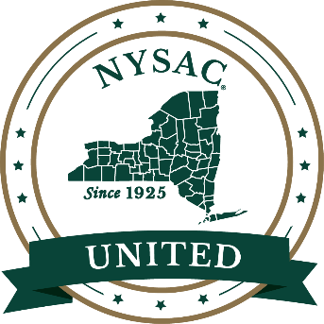
New York State Association of Counties
www.NYSAC.org
info@nysac.org
(518) 465-1473

